THE DEFINITIVE GUIDE TO STM32F103C8 GPIO PINS AND THEIR
ALTERNATE FUNCTIONS


WARNING !! WORK IN PROGRESS, MAY HAVE MISTAKES
GPIO means general-purpose input/output
The STM32F103C8 has 37 GPIOs dispatched on three ports:
GPIOA: 16 pins (PA0 – PA15).
GPIOB: 16 pins (PB0 – PB15).
GPIOC: 3 pins (PC13 – PC15).
GPIOD: 2 pins (PD0 – PD1).

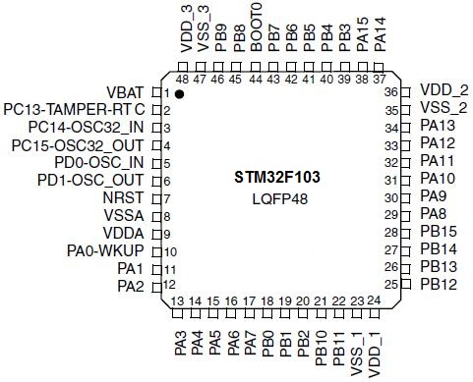

And here is the GPIOs as exposed on the BluePill:

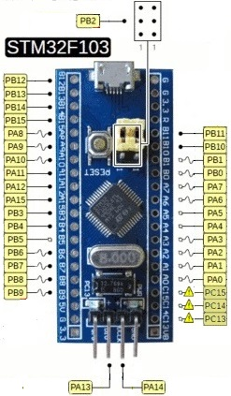

On the Blue Pill board:
- GPIOA pins PA13 and PA14 are used for the SWO interface (for programming and debugging using STLINK-V2).
- GPIOB pin PB2 is used as Boot1 to select boot mode, it’s connected to a 100K resistor which we can pull it up or down via a jumber.

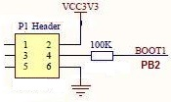

- GPIOC pin PC13 is connected to the cathode of a green LED, it’s anode is tied to +3.3Vthrough a 510Ohm resistor .

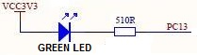

- GPIOC pins PC14-PC15 are connected to a 32 KHz cristal used for RTC. They are exposed on the board so we can use them.
- GPIOD pins PD0 – PD1 are used to connect the external 8MHz cristal, they are not exposed to user, we can use theme if we solder wires to these pins on the PCB (no need to desolder the cristal). The board can still work because it has an internal 8MHz RC oscillator which is used at start-up.

Each of the GPIO pins can be individually configured by software as output (push-pull or open-drain), as input (with or without pull-up or pull-down) or as peripheral alternate function.
-Input floating
-Input pull-up
-Input-pull-down
-Analog
-Output open-drain
-Output push-pull
-Alternate function push-pull
-Alternate function open-drain

USING GPIOs MAIN FUNCTION (digital input/output):
Each GPIO pin is freely programmable as digital input or output by configuring the port via a set of registers.

NOTE: Although each pin can independently programmed, however the I/O port registers have to be accessed as 32-bit words (half-word or byte accesses are not allowed).

Each GPIO port has 7 registers to control it’s behavior. We will see the details later, at the moment we interest only on some of them.
- Control registers low and high (GPIOx_CRL and GPIOx_CRH):
These are 32bit registers used to config the IO pins.
- The 7 low IO pins Px0-Px7: controlled through GPIOx_CRL.
- The 7 high IO pins Px8-Px15: controlled through GPIOx_CRH.
- Output data register (GPIOx_ODR): in input mode we can activate/ deactivate the pull-up/down resistors through it.

Here’s the structure of a GPIOx_CRL register ( GPIOx_CRH is similar).

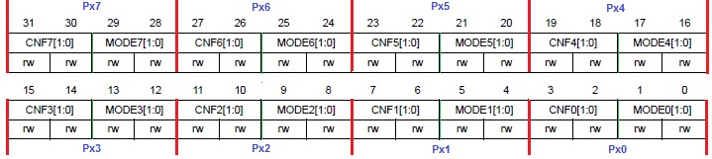

Replace x with the GPIO name. For GPIOA port replace x with A, and Px0 will be PA0:
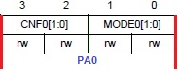

Each pin is controlled by 4bits: CNFn[1:0], 2 bits for configuration and MODEn[1:0], 2 bits for mode. where “n” is the pin number (n = 0 to 15).
NOTE: in the ref man they are ….. CNFx[1:0] and MODEx[1:0], I prefer using “n” instead of “x” to avoid confusion with the “x” in GPIOx.

In GPIOx_CRL: Bits 0 to 3 control the behavior of Px0, bits 4 to 7 control Px1, …etc until Px7.
In GPIOx_CRH: Bits 0 to 3 control the behavior of Px8, bits 4 to 7 control Px9, …etc until Px15.
We will see how to use this 4 bits to control the IO pin later.
And here’s the structure of a GPIOx_ODR register:

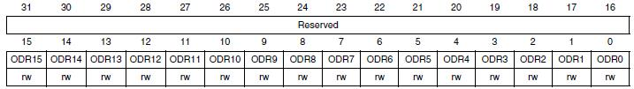

In input mode each of the low 16 bits is used to activate/ deactivate the pull-up/down resistor of the corresponding IO pin.
ODR_{n} = 0 ➔Pull-down for Px_{n} activated, ODR_{n} = 1 ➔Pull-up for Px_{n} activated. Where n = 0, 1, ….. 15.
Example for GPIOB : ODR12 = 1 ➔ pull-up for pin PB12 is activated (if it’s configured as input of course).

The basic structure of a standard IO pin is:

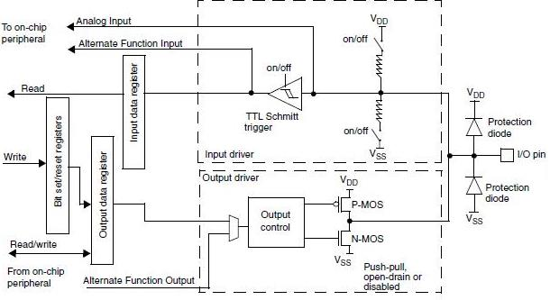

* The I/O pin is :
- protected against over voltage using internal diodes. In place of V_{DD}, 5-Volt tolerant I/Os have specific potential (V_{DD_FT}), different from V_{DD}.
- Connected to two resistors, one in the VDD side (pull-up) and the other one in the VSS side (pull-down), which in input mode we can connect/disconnect them to/from VDD or VSS respectively by closing/opening internal switches controlled by the output data register (ODR) of the concerned port.
- Connected to two FET transistors, one a P type in the VDD side (push) and the other one an N type in the VSS side (pull). In output mode we can activate or deactivate the P FET to choose between push-pull or open drain mode respectively.

After reset, all the GPIOs are configured in Input Floating mode (CNFx[1:0]=01b, MODEx[1:0]=00b), and the alternate functions are not active.
If we need a pin as input we can use it without any configuration if the connected logic can drive it high or low.
If the this input pin is connected to the output of an open drain gate we must then pull it up to +3.3V with a resistor (any value between 4.7k and 10k works well). We will see next how to activate the internal pull-up resistor.

Input configuration:
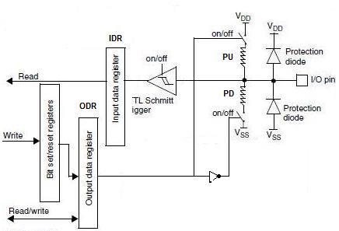

When the I/O pin is programmed as Input:
- The Output Buffer is disabled.
- The Schmitt Trigger Input is activated.
- The data present on the I/O pin is sampled into the Input Data Register every APB2 clock cycle.
- A read access to the Input Data Register obtains the I/O State.

Activating/deactivating pull-up/down resistors:
All GPIO pins have an internal weak pull-up and weak pull-down that can be activated or not when configured as input.
After reset all GPIOs are in input floating mode (CNF[1:0] = 01), where the pull-up (PU) resistor is NOT connected to VDD and the pull-down (PD) resistor is NOT connected to VSS.
In input mode, the 2 bits MODE_{n}[1:0] for pin Px_{n} must be equal to “00” (x= A, B, C and n=0,1,2 ….15).
We can activate the PU OR PD resistor (only one at a time) using config bits CNF[1:0] in GPIOx control register (GPIOx_CR) in combination with GPIOx output data register (GPIOx_ODR). ODR can be accessed directly or through BSRR or BRR registers.

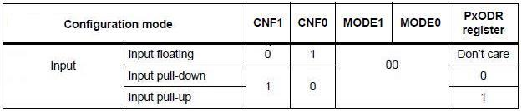

Example:
To connect a push button to the pin PB0 (and to avoid an extra resistor).
- Case1: If we want to connect the button to +VDD we need to configure the pin as input with pull-down.
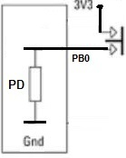

- case2: If we want to connect the button to GND we need to configure the pin as input with pull-up.

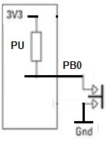
We’ll see the code examples later.
Note: When using mechanical buttons we must do a software debouncing (delay of about 250ms before reading the state of the button).

Output configuration:

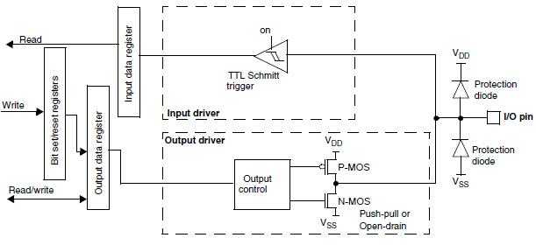
When the I/O Port is programmed as Output:
-The Output Buffer is enabled:
– Open Drain Mode: A “0” in the Output register activates the N-MOS while a “1” in the Output register leaves the port in Hi-Z (the P-MOS is never activated).
– Push-Pull Mode: A “0” in the Output register activates the N-MOS while a “1” in the Output register activates the P-MOS.
-The Schmitt Trigger Input is activated.
-The weak pull-up and pull-down resistors are disabled.
-The data present on the I/O pin is sampled into the Input Data Register every APB2 clock cycle.
-A read access to the Input Data Register gets the I/O state in open drain mode.
- A read access to the Output Data register gets the last written value in Push-Pull mode.

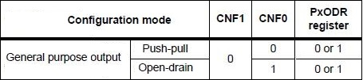

When configured as output, the value written to the Output Data register (GPIOx_ODR) is output on the I/O pin. It is possible to use the output driver in Push-Pull mode or Open-Drain mode (only the N-MOS is activated when outputting 0).
The Input Data register (GPIOx_IDR) captures the data present on the I/O pin at every APB2 clock cycle.

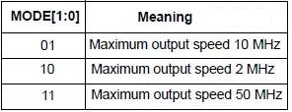

Atomic bit set or reset:
To allow atomic read/modify accesses to any of the GPIO pins, each port has two registers for this purbose, the bit set reset register (GPIOx_BSRR) and the bit reset rgister (GPIOx_BRR).
There is no need for the software to disable interrupts when programming the GPIOx_ODR at bit level: it is possible to modify only one or several bits in a single atomic APB2 write access. This is achieved by programming to ‘1’ the Bit Set/Reset Register (GPIOx_BSRR, or for reset only GPIOx_BRR) to select the bits to modify. The unselected bits will not be modified.
This way, there is no risk that an IRQ occurs between the read and the modify access.

Alternate function I/O (AFIO):
All GPIO pins have an alternate function related to a peripheral on the device.
After reset the default mapping function → pin is :

PERIHERAL | FUNCTION | PIN | REMAPPABLE
OSC32 | OSC32_IN | PC14 | NO
OSC32 | OSC32_OUT | PC15 | NO
OSC | OSC_IN | PD0 | NO
OSC | OSC_OUT | PD1 | NO
CAN | CAN_RX | PA11 | YES
CAN | CAN_TX | PA12 | YES
TIMER1 | TIM1_CH1 | PA8 | NO
TIMER1 | TIM1_CH2 | PA9 | NO
TIMER1 | TIM1_CH3 | PA10 | NO
TIMER1 | TIM1_CH4 | PA11 | NO
TIMER1 | TIM1_ETR | PA12 | NO
TIMER1 | TIM1_BKIN | PB12 | YES
TIMER1 | TIM1_CH1N | PB13 | YES
TIMER1 | TIM1_CH2N | PB14 | YES
TIMER1 | TIM1_CH3N | PB15 | YES
TIMER2 | TIM2_CH1_ETR | PA0 | YES
TIMER2 | TIM2_CH2 | PA1 | YES
TIMER2 | TIM2_CH3 | PA2 | YES
TIMER2 | TIM2_CH4 | PA3 | YES
TIMER3 | TIM3_CH1 | PA6 | YES
TIMER3 | TIM3_CH2 | PA7 | YES
TIMER3 | TIM3_CH3 | PB0 | NO
TIMER3 | TIM3_CH4 | PB1 | NO
TIMER4 | TIM4_CH1 | PB6 | NO
TIMER4 | TIM4_CH2 | PB7 | NO
TIMER4 | TIM4_CH3 | PB8 | NO
TIMER4 | TIM4_CH4 | PB9 | NO
USART1 | USART1_CK | PA8 | NO
USART1 | USART1_TX | PA9 | YES
USART1 | USART1_RX | PA10 | YES
USART1 | USART1_CTS | PA11 | NO
USART1 | USART1_RTS | PA12 | NO
USART2 | USART2_CTS | PA0 | NO
USART2 | USART2_RTS | PA1 | NO
USART2 | USART2_TX | PA2 | NO
USART2 | USART2_RX | PA3 | NO
USART2 | USART2_CK | PA4 | NO
USART3 | USART3_TX | PB10 | NO
USART3 | USART3_RX | PB11 | NO
USART3 | USART3_CK | PB12 | NO
USART3 | USART3_CTS | PB13 | NO
USART3 | USART3_RTS | PB14 | NO
I2C1 | I2C1_SCL | PB6 | YES
I2C1 | I2C1_SDA | PB7 | YES
I2C2 | I2C2_SCL | PB8 ? | NO
I2C2 | I2C2_SDA | PB9 ? | NO
SPI1 | SPI1_NSS | PA4 | YES
SPI1 | SPI1_SCK | PA5 | YES
SPI1 | SPI1_MISO | PA6 | YES
SPI1 | SPI1_MOSI | PA7 | YES
SPI2 | SPI2_NSS | PB12 | NO
SPI2 | SPI2_SCK | PB13 | NO
SPI2 | SPI2_MISO | PB14 | NO
SPI2 | SPI2_MOSI | PB15 | NO
USB | USB- | PA11 | NO
USB | USB+ | PA12 | NO
JTAG/SWD | JTMS / SWDIO | PA13 | NO
JTAG/SWD | JTCK / SWCLK | PA14 | NO
JTAG/SWD | JTDI | PA15 | NO
JTAG/SWD | JTDO / TRACESWO | PB3 | NO
JTAG/SWD | NJTRST | PB4 | NO

So after reset some pins are assigned to different functions :

PIN | UAR1 | UAR2 | UAR3 | TIM1 | TIM2 | TIM3 | TIM4 | SPI1 | SPI2 | I2C1 | I2C2 | CAN | ADC | USB
PA0 |  | CTS |  |  | CH1_ETR |  |  |  |  |  |  |  | ADC0
PA1 |  | RTS |  |  | CH2 |  |  |  |  |  |  |  | ADC1
PA2 |  | TX |  |  | CH3 |  |  |  |  |  |  |  | ADC3
PA3 |  | RX |  |  | CH4 |  |  |  |  |  |  |  | ADC4
PA4 |  | CK |  |  |  |  |  | NSS |  |  |  |  | ADC5
PA5 |  |  |  |  |  | CH1 |  | SCK |  |  |  |  | ADC6
PA6 |  |  |  |  |  | CH2 |  | MISO |  |  |  |  | ADC7
PA7 |  |  |  |  |  |  |  | MOSI
PA8 | CK |  |  | CH1
PA9 | TX |  |  | CH2
PA10 | RX |  |  | CH3
PA11 | CTS |  |  | CH4 |  |  |  |  |  |  |  | RX |  | D-
PA12 | RTS |  |  | ETR |  |  |  |  |  |  |  | TX |  | D+
PA13
PA14
PA15
PB0 |  |  |  |  |  | CH3 |  |  |  |  |  |  | ADC8
PB1 |  |  |  |  |  | CH4 |  |  |  |  |  |  | ADC9
PB2
PB3
PB4
PB5
PB6 |  |  |  |  |  |  | CH1 |  |  | SCL
PB7 |  |  |  |  |  |  | CH2 |  |  | SDA
PB8 |  |  |  |  |  |  | CH3 |  |  |  | SDA
PB9 |  |  |  |  |  |  | CH4 |  |  |  | SCL
PB10 |  |  | TX
PB11 |  |  | RX
PB12 |  |  | CK | BKIN |  |  |  |  | NSS
PB13 |  |  | CTS | CH1N |  |  |  |  | SCK
PB14 |  |  | RTS | CH2N |  |  |  |  | MISO
PB15 |  |  |  | CH3N |  |  |  |  | MOSI

Alternate function configuration:

Before using a default alternate function It is necessary to program the Port Bit Configuration Register .
If a pin is configured as Alternate Function Output, this disconnects the output register and connects the pin to the output signal of an on-chip peripheral.

* When the I/O Port is programmed as Alternate Function output:
− The Output Buffer is turned on in Open Drain or Push-Pull configuration
− The Output Buffer is driven by the signal coming from the peripheral (alternate function out)
− The Schmitt Trigger Input is activated
− The weak pull-up and pull-down resistors are disabled.
− The data present on the I/O pin is sampled into the Input Data Register every APB2 clock cycle
− A read access to the Input Data Register gets the I/O state in open drain mode
− A read access to the Output Data register gets the last written value in Push-Pull mode.

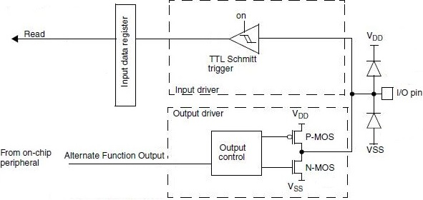

For alternate function output, the pin must be configured in Alternate Function Output mode (Push-Pull or Open-Drain).

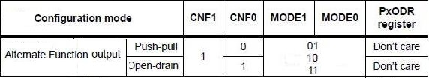

* When the I/O Port is programmed as Alternate Function input:
− The Output Buffer is turned off .
− The Schmitt Trigger Input is activated.
- ODR is used to activate/deactivate pull-up/down resistors.

For alternate function inputs, the pin must be configured in Input mode (floating, pull-up or pull-down this depend on the function) and the input pin must be driven externally.

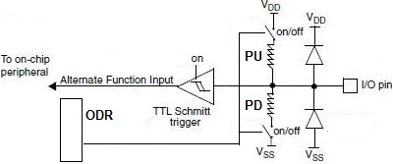

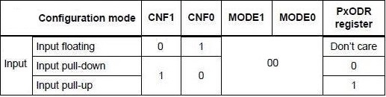

Note: It is also possible to emulate the AFI input pin by software by programming the GPIO
controller. In this case, the port should be configured in Alternate Function Output mode.
And obviously, the corresponding port should not be driven externally as it will be driven by
the software using the GPIO controller.

* For bidirectional Alternate Functions, the pin must be configured in Alternate Function Output mode (Push-Pull or Open-Drain). In this case the input driver is configured in input floating mode.
* If software configures a pin as Alternate Function Output, but peripheral is not activated, its output is not specified.

Analog configuration:
When the I/O Port is programmed as Analog input for ADC :
− The Output Buffer is disabled.
− The Schmitt Trigger Input is de-activated providing zero consumption for every analog value of the I/O pin. The output of the Schmitt Trigger is forced to a constant value (0).
− The weak pull-up and pull-down resistors are disabled.
− Read access to the Input Data Register gets the value “0”.

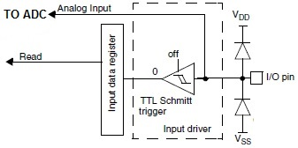
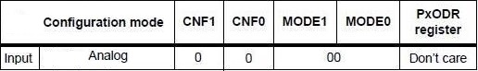

GPIO configurations for device peripherals:
Advanced timer (TIM1):
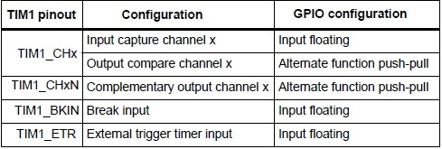
General purpose timers (TIM2/3/4):
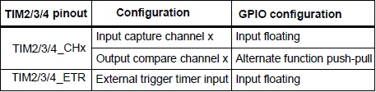
USARTs:
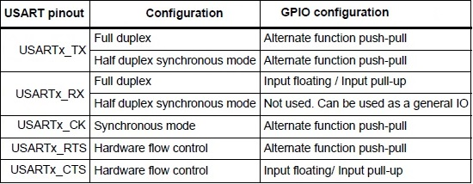
SPI:
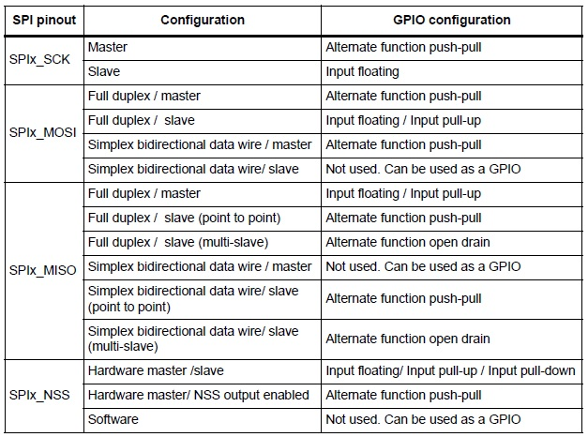
I2C:
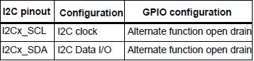
CAN:
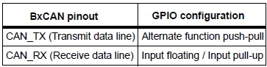
USB:
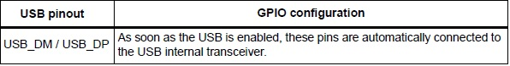
ADC:
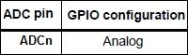
Where n = 0, 1, …..9.
Other I/O:
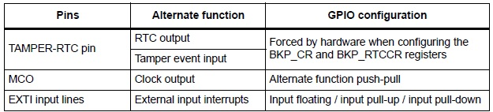

Software remapping of I/O alternate functions:
To optimize the number of peripherals available, Most of the GPIO pins are shared with digital or analog alternate functions. It is possible to remap some alternate functions to some other pins. This is achieved by software, by programming the AF remap and debug I/O configuration register (AFIO_MAPR). In this case, the alternate functions are no longer mapped to their original assignations.

Here is the AF remap and debug I/O configuration register (AFIO_MAPR):

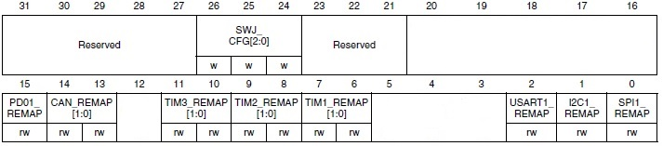

The I/Os alternate function configuration can be locked if needed following a specific sequence in order to avoid spurious writing to the I/Os registers.

Using OSC32_IN/OSC32_OUT pins as GPIO ports PC14/PC15:
The LSE oscillator pins OSC32_IN and OSC32_OUT can be used as general-purpose I/O PC14 and PC15, respectively, when the LSE oscillator is off. The LSE has priority over the GP IOs function.
Note: The PC14/PC15 GPIO functionality is lost when the 1.8 V domain is powered off (by entering standby mode) or when the backup domain is supplied by VBAT (VDD no more supplied). In this case the IOs are set in analog mode.
Refer to the note on IO usage restrictions in Section 5.1.2: Battery backup domain.

Using OSC_IN/OSC_OUT pins as GPIO ports PD0/PD1:
The HSE oscillator pins OSC_IN/OSC_OUT can be used as general-purpose I/O PD0/PD1 by programming the PD01_REMAP bit in the AF remap and debug I/O configuration register
(AFIO_MAPR).
Note: The external interrupt/event function is not remapped. PD0 and PD1 cannot be used for external interrupt/event generation.

CAN:
The CAN signals can be remapped from it’s default position on Port A (PA11:PA12) to Port B (PB8:PB9).

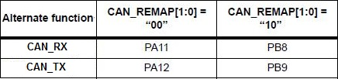

TIMER1:
Only BKIN, CH1N can be remapped from PB12, PB13 to PA6, PA7 respectively and CH2N, CH3N from PB14, PB15 to PB0, PB1 respectively. Other functions can’t be remapped.

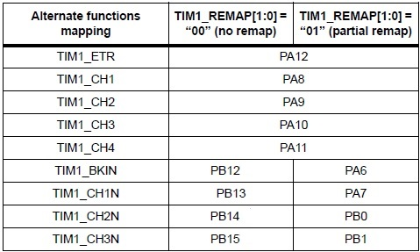

TIMER2:

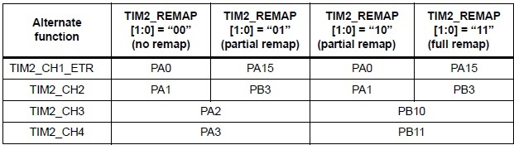
Note: TIM2_CH1 and TIM2_ETR share the same pin but cannot be used at the same time (which is why we have
this notation: TIM2_CH1_ETR).
TIMER3:
Only CH1 and CH2 can be remapped from PA6 and PA7 to PB4 and PB5 respectively. CH3 and CH4 can’t be remapped.

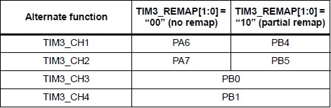
USART1:
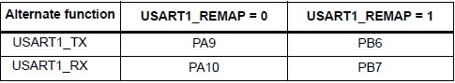
I2C1:
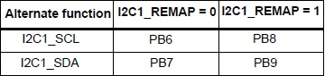
SPI1:
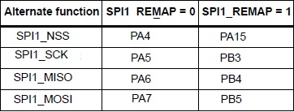
GPIO locking mechanism:
The locking mechanism allows the IO configuration to be frozen. When the LOCK sequence
has been applied on a port bit, it is no longer possible to modify the value of the port bit until
the next reset.
External interrupt/wakeup lines
All ports have external interrupt capability. To use external interrupt lines, the port must be configured in input mode.

Debug configuration:
The JTAG/SWD pins after reset are configured like this:

 | FUNCTION | PIN | Input/Output | Pull-Up/PDown
JTAG/SWD | JTMS / SWDIO | PA13 | I | PU
JTAG/SWD | JTCK / SWCLK | PA14 | I | PD
JTAG/SWD | JTDI | PA15 | I | PU
JTAG/SWD | JTDO / TRACESWO | PB3 | O
JTAG/SWD | NJTRST | PB4 | I | PU

JTAG/SWD configuration:
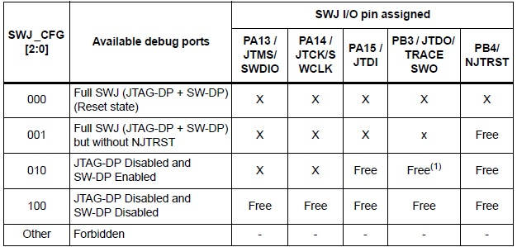
1. Released only if not using asynchronous trace.

PROGRAMMING:
Each GPIO port has seven 32bits registers :
- Two configuration registers (GPIOx_CRL,GPIOx_CRH).
- Two data registers (GPIOx_IDR, GPIOx_ODR),
- Two set/reset registers (GPIOx_BSRR, GPIOx_BRR ),
- One locking register (GPIOx_LCKR).

Where x is A, B, C or D.
The physical base addresses of the GPIO ports are:

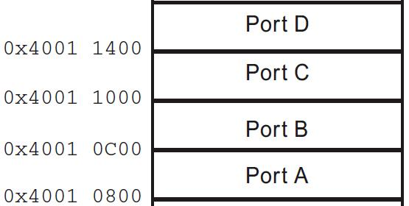
And the registers offsets relative to these base addresses are:
Register | Address offset
Port configuration register low (GPIOx_CRL) | 0x00
Port configuration register high (GPIOx_CRH) | 0x04
Port input data register (GPIOx_IDR) | 0x08
Port output data register (GPIOx_ODR) | 0x0C
Port bit set/reset register (GPIOx_BSRR) | 0x10
Port bit reset register (GPIOx_BRR) | 0x14
Port configuration lock register (GPIOx_LCKR) | 0x18

For example GPIOB_ODR is at address 0x40010C0C and GPIOC_CRH is at address 0x40011004.
The I/O port registers have to be accessed as 32-bit words (half-word or byte accesses are not allowed).
1- Direct access to GPIO registers:
In order to access the port registers for read/write operations we declare a GPIO structure:
typedef struct {
volatile unsigned int CRL ; // 0x00 configuration register low
volatile unsigned int CRH ; // 0x04 configuration register high
volatile unsigned int IDR ; // 0x08 Input data register
volatile unsigned int ODR ; // 0x0C Output data register
volatile unsigned int BSRR ; // 0x10 Bit set/reset register
volatile unsigned int BRR ; // 0x14 Bit reset register
volatile unsigned int LCKR ; // 0x18 lock register
} GPIO ;

Note: we use volatile …….
Then we define the ports as pointers to structures of type GPIO like this:

#define GPIOA ((GPIO *) 0x40010800) // PORT A Base address
#define GPIOB ((GPIO *) 0x40010C00) // PORT B Base address
#define GPIOC ((GPIO *) 0x40011000) // PORT C Base address
#define GPIOD ((GPIO *) 0x40011400) // PORT D Base address

For example:
- To read the state of port A pins:

Unsigned int x = GPIOA->IDR;

- To write the value 0xDEADBEEF in port B CRH:

GPIOB->CRH = 0xDEADBEEF;

Remapping:
//Remap MOSI1 from PA7 to PB5
// Configure PORTB Pin5 as alternate function output Push pull 50 MHz
PORTB->CRL |= 0x00B00000;

// we must disable JTAG and SW on PORTB
AFIO->MAPR &= 0xF0FFFFFF; // ~(7<<24) reset bits(26:24)
AFIO->MAPR |= 0x04000000; // 4<<24 bits(26:24) = 100 => disable JTAG-DP and SW-DP

// config AFIO_MAPR Bit0 (SPI1_REMAP)
AFIO->MAPR |= 1<<0; // Bit0 = 1 => Remap (NSS/PA15, SCK/PB3, MISO/PB4, MOSI/PB5)

2- Access to GPIO registers using CMSIS:

GPIO_PinRemapConfig(GPIO_Remap_SWJ_JTAGDisable, ENABLE); // disable JTAG
GPIO_PinRemapConfig(GPIO_FullRemap_TIM2, ENABLE); // Ful remap TIM2
Electrical characteristics:
I/Os on APB2 with up to 18 MHz toggling speed.

All GPIOs are high current-capable.
Typical values
Unless otherwise specified, typical data are based on TA = 25 °C, VDD = 3.3 V (for the 2 V ≤ VDD ≤ 3.6 V voltage range). They are given only as design guidelines and are not tested !!!
All I/Os are CMOS and TTL compliant.

Output driving current page 65
The GPIOs (general-purpose inputs/outputs) can sink or source up to ±8 mA, and sink or source up to ±20 mA (with a relaxed VOL/VOH) except PC13, PC14 and PC15 which can sink or source up to +/-3mA. When using the GPIOs PC13 to PC15 in output mode, the speed should not exceed 2 MHz with a maximum load of 30 pF.
In the user application, the number of I/O pins which can drive current must be limited to respect the absolute maximum rating specified in Section 5.2:
-The sum of the currents sourced by all the I/Os on VDD, plus the maximum Run
consumption of the MCU sourced on VDD, cannot exceed the absolute maximum rating
IVDD (see Table 7).
-The sum of the currents sunk by all the I/Os on VSS plus the maximum Run
consumption of the MCU sunk on VSS cannot exceed the absolute maximum rating
IVSS (see Table 7).
Output voltage levels
Unless otherwise specified, the parameters given in Table 36 are derived from tests performed under ambient temperature and VDD supply voltage conditions summarized in Table 9. All I/Os are CMOS and TTL compliant.

Power supply schemes
-VDD = 2.0 to 3.6 V: external power supply for I/Os and the internal regulator.
Provided externally through VDD pins.
-VSSA, VDDA = 2.0 to 3.6 V: external analog power supplies for ADC, reset blocks, RCs
and PLL (minimum voltage to be applied to VDDA is 2.4 V when the ADC is used).
VDDA and VSSA must be connected to VDD and VSS, respectively.
-VBAT = 1.8 to 3.6 V: power supply for RTC, external clock 32 kHz oscillator and backup registers (through power switch) when VDD is not present.

